Odoo Server Configurations, Module Structure and Types of Models

- How to create config file and explore all the basic parameters of config.
→
The odoo.conf file is essential for setting up Odoo, The Odoo configuration file is usually located in the Odoo installation directory or specified during the Odoo server startup using the -c or --config argument.

--Example of a basic Odoo configuration file--

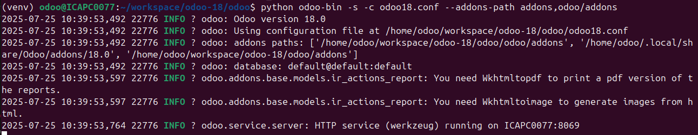
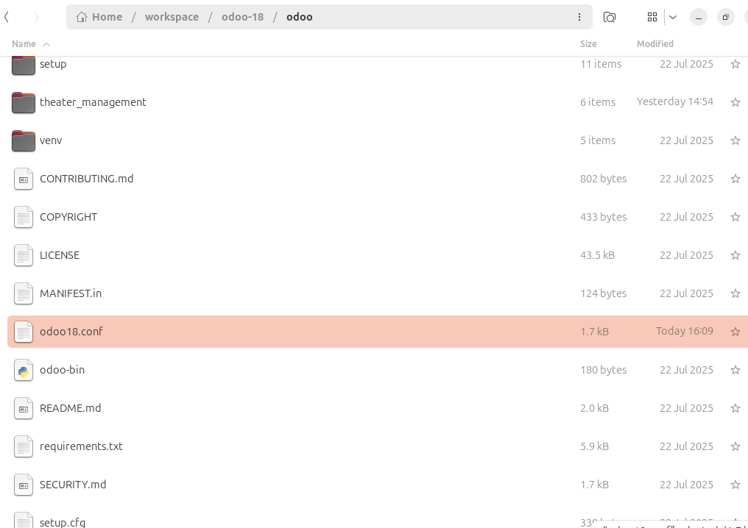
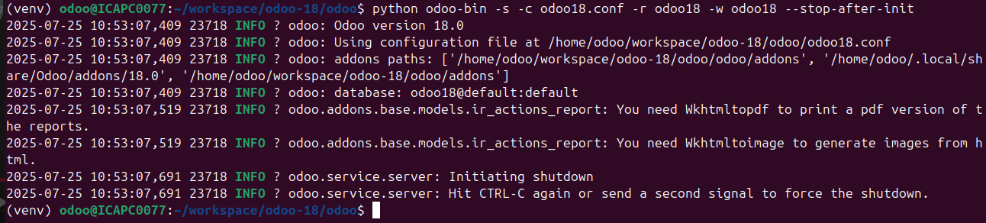
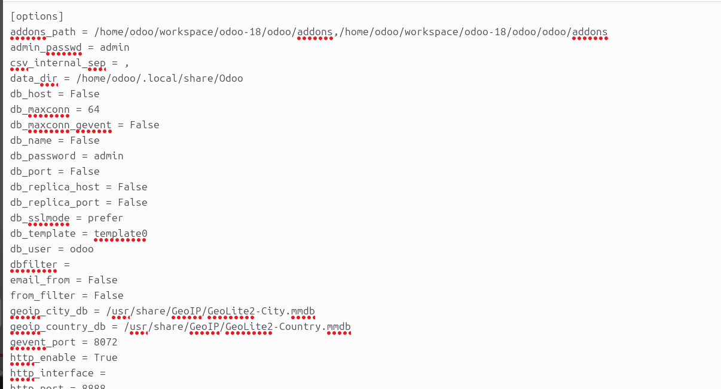
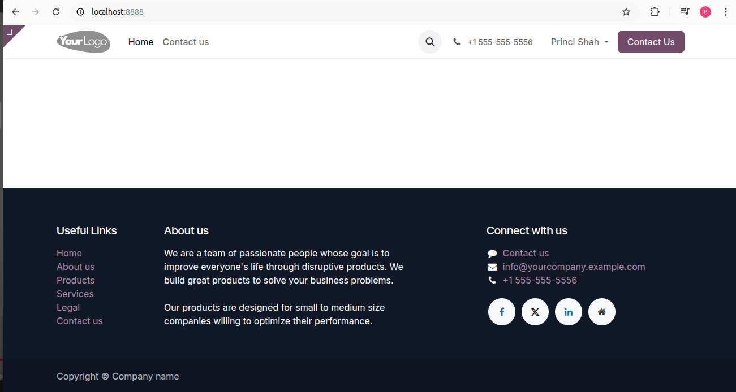
- Learn how to configure an Odoo service using Pycharm.
→

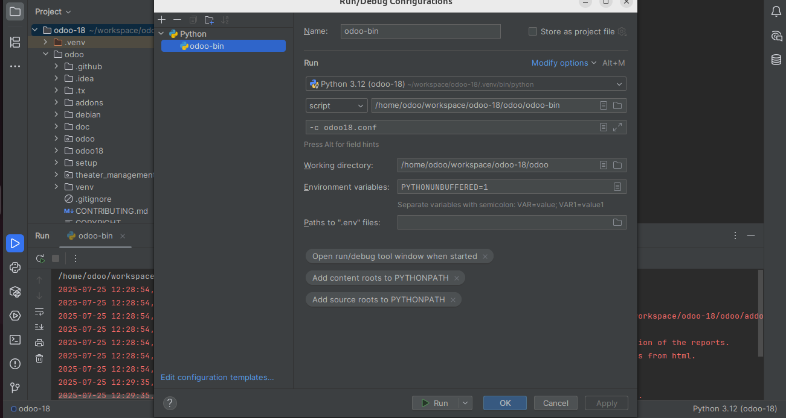
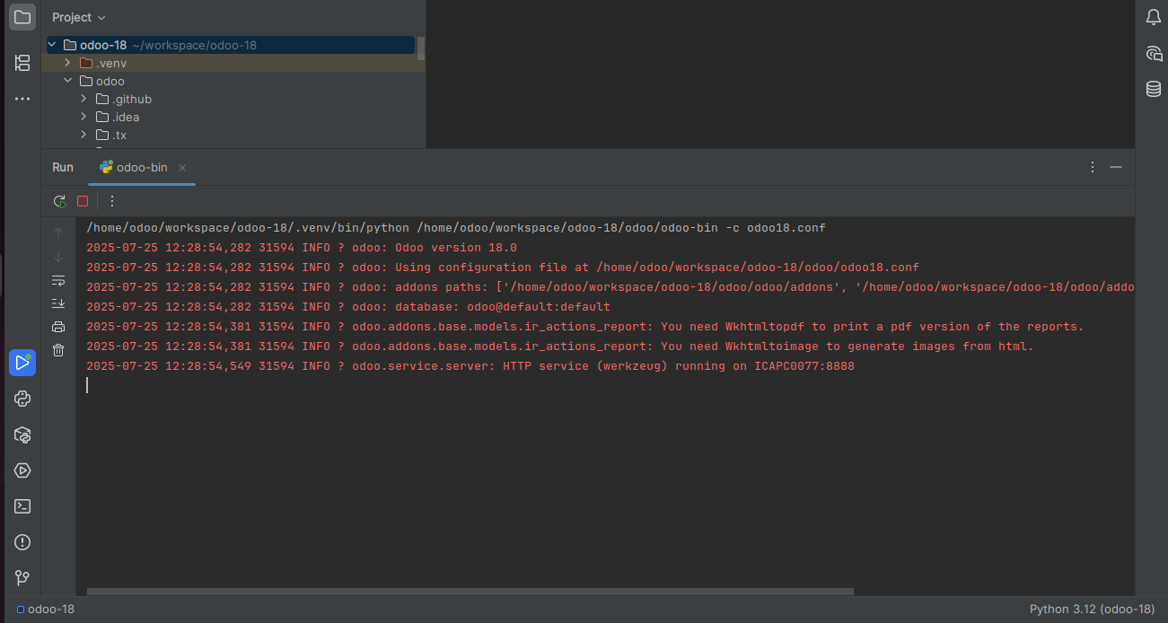
- Create a new module [Containing models only] and explore the manifest file in detail.
→
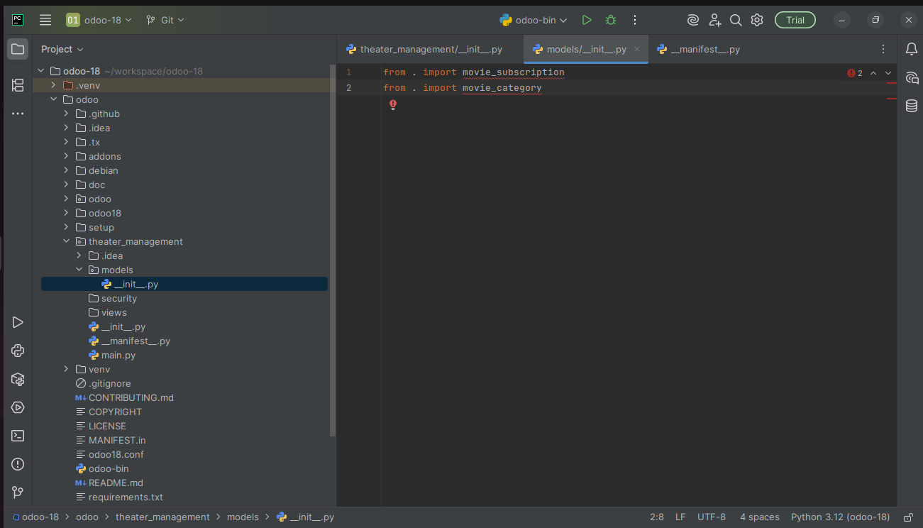
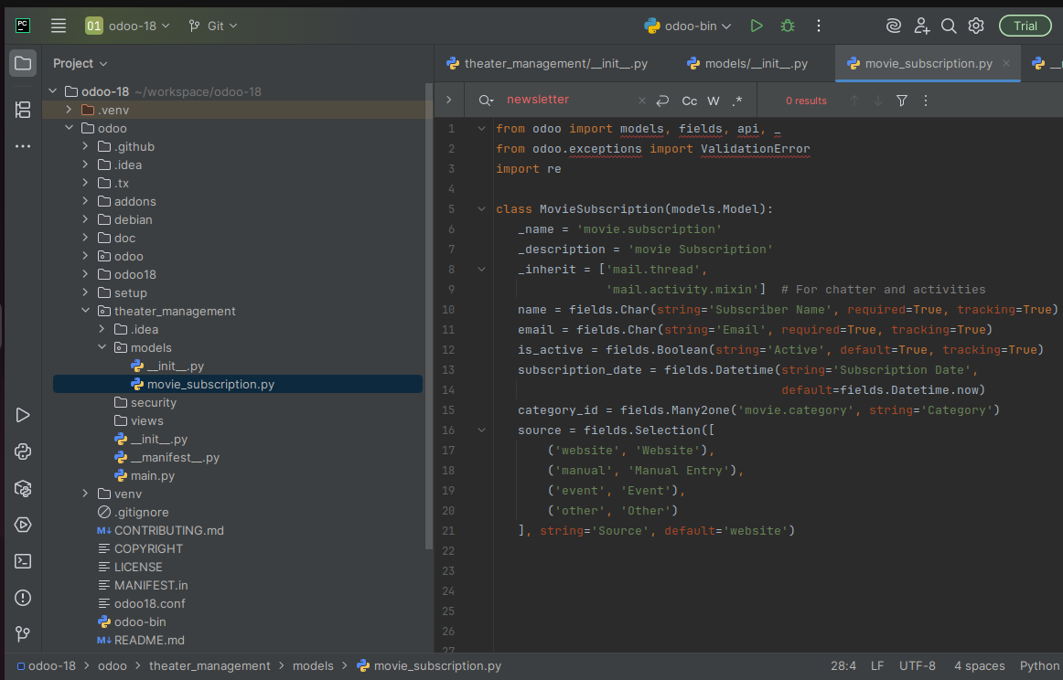
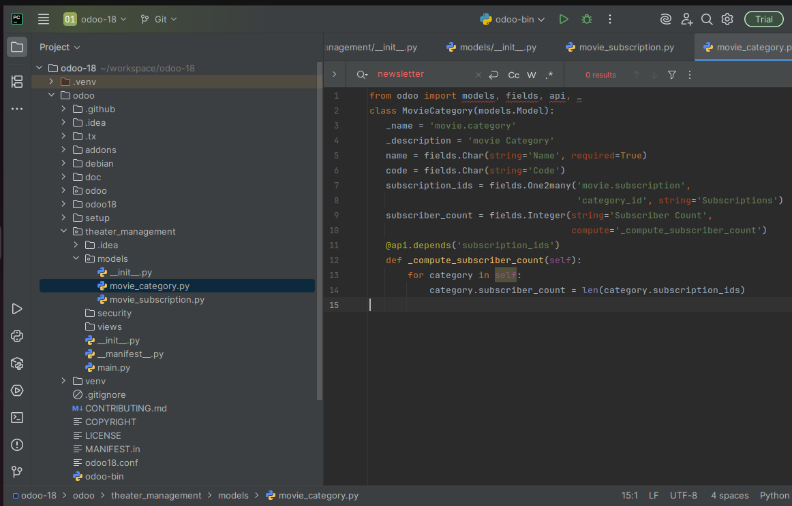
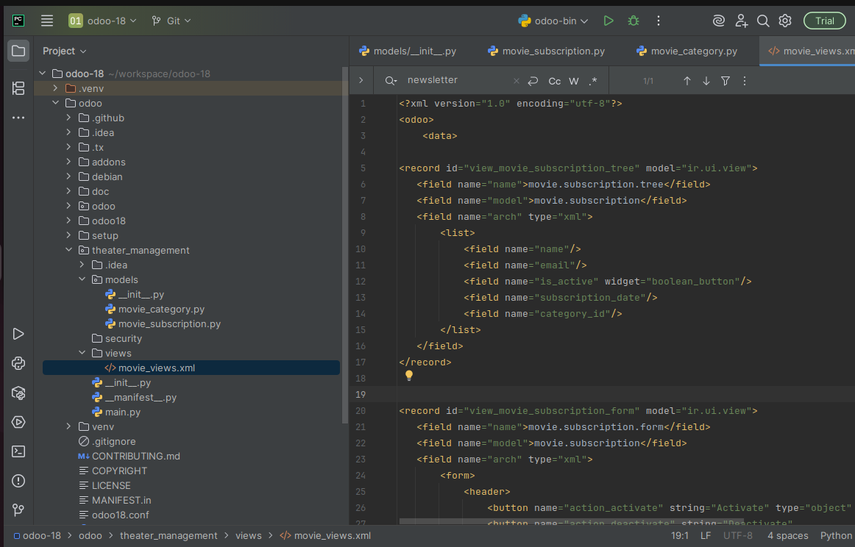
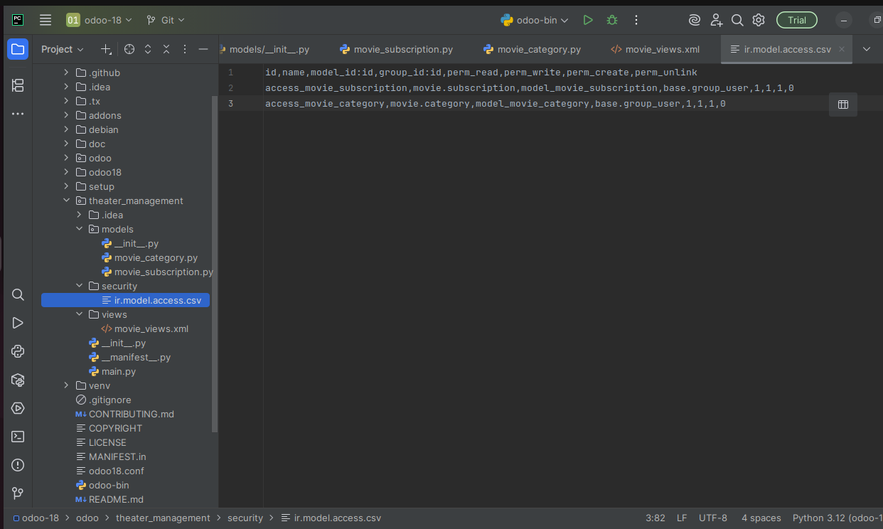
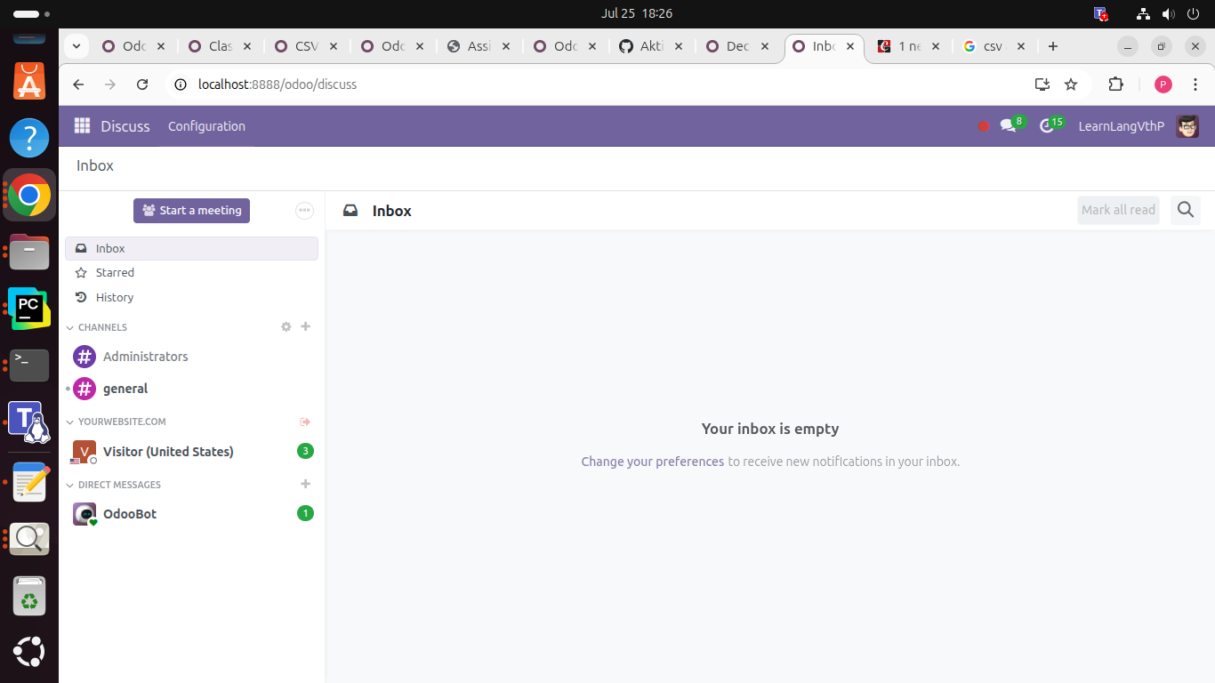
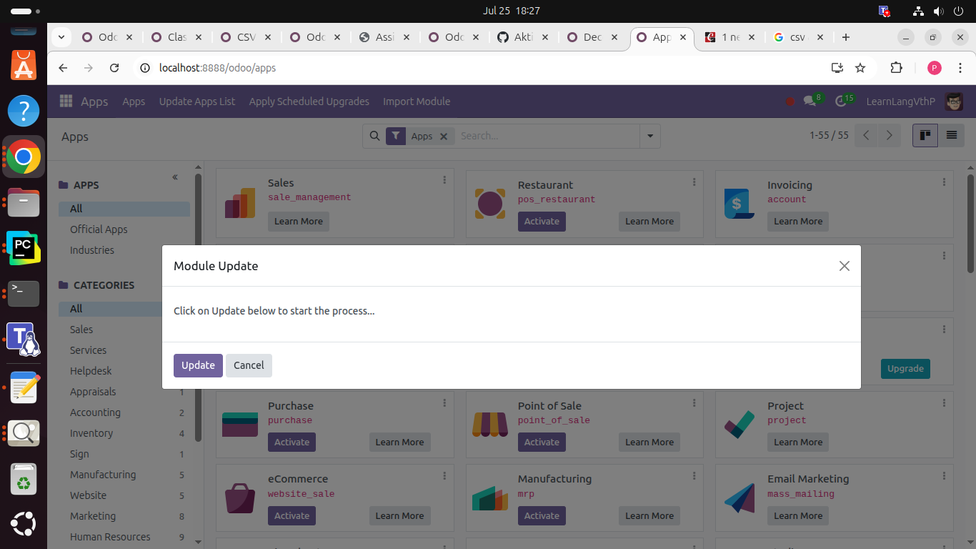

- Same as the example of sending emails from sale or purchase, Prepare an example which demonstrates the use of normal model, abstract model and the transient models. [Only need to prepare a document containing functional explaination].
→
I don’t know how to make it !

